Youth of Unity Breakfast Fundraiser March 19th!
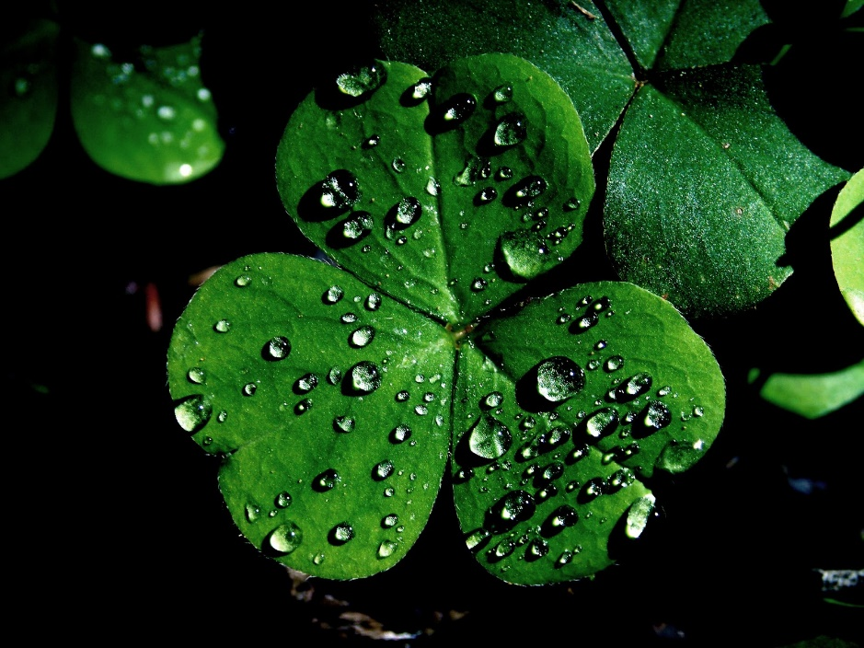
Suggested love offering $5
All money raised goes to sending our Y.O.U. and Uniteens on upcoming retreats & rally’s
If you are interested in donating breakfast meats, fruit, bagels, juice, quiche, and/or vegetarian items please contact Sally at 732-241-1255. Thank you for your support!

