Sunday October 30th
Come join us for a Spooktacular Halloween Breakfast
$5 per person- $10 per family

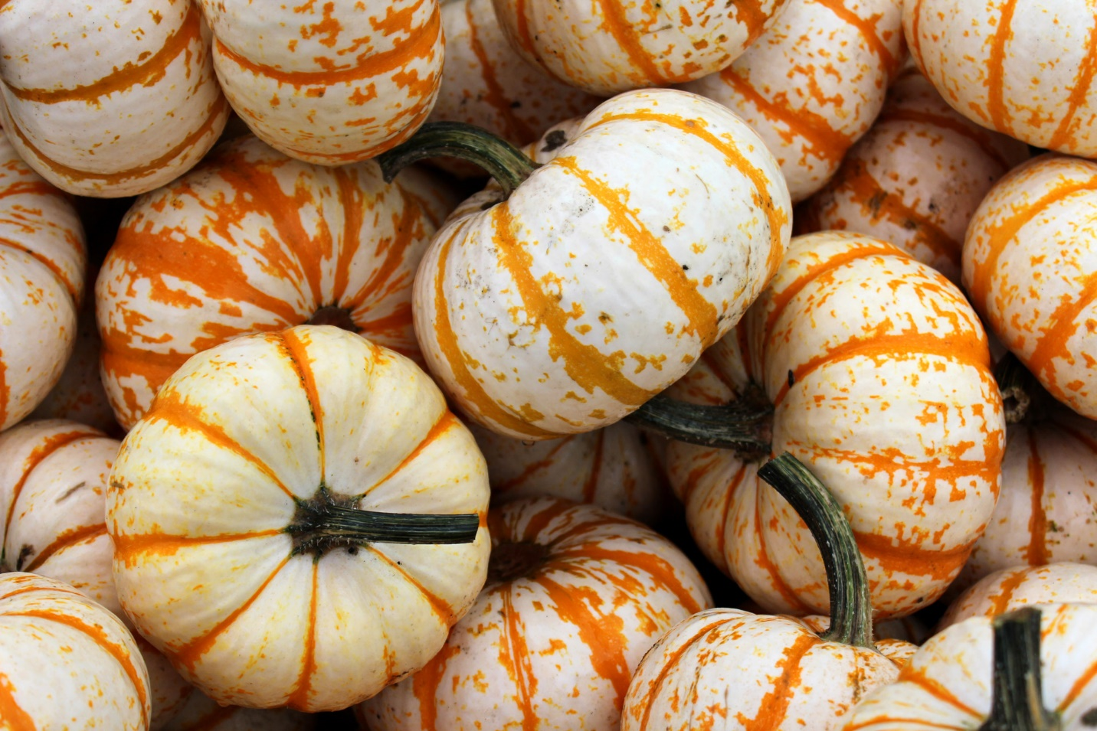
All proceeds will go to sending our
Uniteens/Y.O.U.’s on upcoming Retreats/Rally’s
Thank you!

