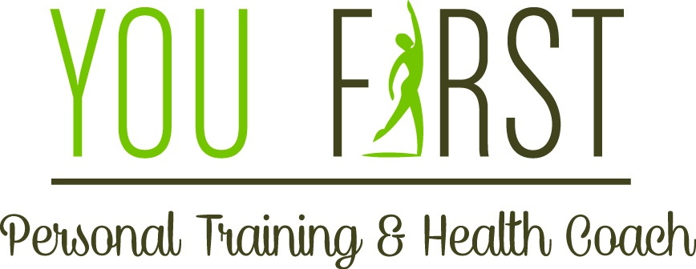

6 Week
Fitness Boot Camp
Are you looking to improve your overall health and fitness? Tone up and get in shape? What better time to start then now?

Time: 6:00 PM

Class Dates: Thursday
May 4, 11, 18
June 1, 8, 15

Location: Unity by the Shore
3508 Asbury Ave, Neptune
Class will be held outdoors

Register at
http://youfirstpersonaltrainer.vpweb.com/

What you will need: A yoga mat for relaxation/meditation, water, and a towel
Please bring any weights or fitness bands you may already own to class to ensure we have enough to share.

Love offering: $65.00(paid in full) for all 6 sessions
Committing to yourself for six weeks insures our common goal of
Increasing your fitness, health, and happiness

Program includes:
- Bodyweight strength building
- Speed and agility
- Relaxation/meditation
- Opportunity for personalized workout programs and nutrition information

You First Personal Training Owner ~ Vicky Farrell
Certified NASM Personal Trainer, Certified NASM Fitness Nutrition Specialist, TRX Certified, Certified Coach
For more information – Call (732)610-6486 – email youfirstptlc@hotmail.com – Facebook Vicky Farrell You First Personal Training & Health Coach

