Unity and A Course in Miracles
Authors: William Heller & Paul Hasselbeck
12 Week Book Study Thursdays 1-3 PM
Commencing January 12, 2017

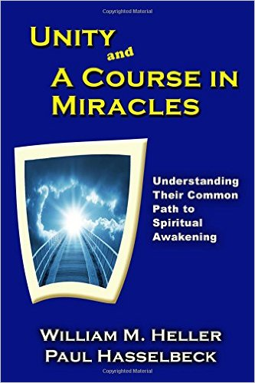
Come and explore the similarities and distinctions between two spiritual paths where the foundational tenets are rooted in Love and Oneness as the Master Teacher Jesus exemplified. Come learn how these 2 teachings are harmonious and support the evolution of your consciousness and your ability to be the embodiment of Divine Love and Wisdom at work in the world.
William Heller, co-author of Unity and a Course of Miracles, will present a workshop on the evening of January 11, 2017, from 6:30-8:30. What a wonderful way to kick off your study whether done here at UBTS or personally done by you on your own.
Book Study Facilitated by: Angela Denton MA; P.D. MFT; LUT
Cost: Love Offering
Required Text: Unity and a Course of Miracles (books can be purchased at UBTS)

